SE Lab – Week 1
Date: 22 July 2025

SRS – Software Requirement Specification
Structure of an SRS document
1. Abstract
KScan is an AI-based document verification mobile application. It is used for verifying the document by performing similarity matching between the user-entered profile details and extracted text from the specific document. The ultimate goal of this application is to verify whether the document is fake or real.

2. Functional Requirements (FR):
FR1 → The user shall be able to sign up using email ID.

FR2 → The user shall be able to fill the profile details.

FR3 → The user shall be able to upload the document and choose document type in order to verify specific document.

3. Non-Functional Requirements (NFR):
NFR1 → The application shall be available all the time in order to process the user request.

NFR2 → The application should handle maximum users up to 200 initially.

NFR3 → The application should verify the document correctly in order to avoid any inconvenience.

NFR4 → The application should be load in 5 sec.

4. Workflow
Registered User Workflow:

a) Registration and Setup
→ Install the app
→ Enter phone number
→ Verify the user via OTP
→ Login successfully

b) Profile Details
→ Enter name
→ Enter email ID
→ Enter document-specific details

c) Verification
→ Upload document
→ Select document type
→ Attach supporting image
→ Submit

d) Report Generation
→ A full-fledged report describing the verification result indicating fake or real document on the basis of some criteria

5. User:
1.Registered Users
2. Admin
3. System

6.Use Case Diagram :-
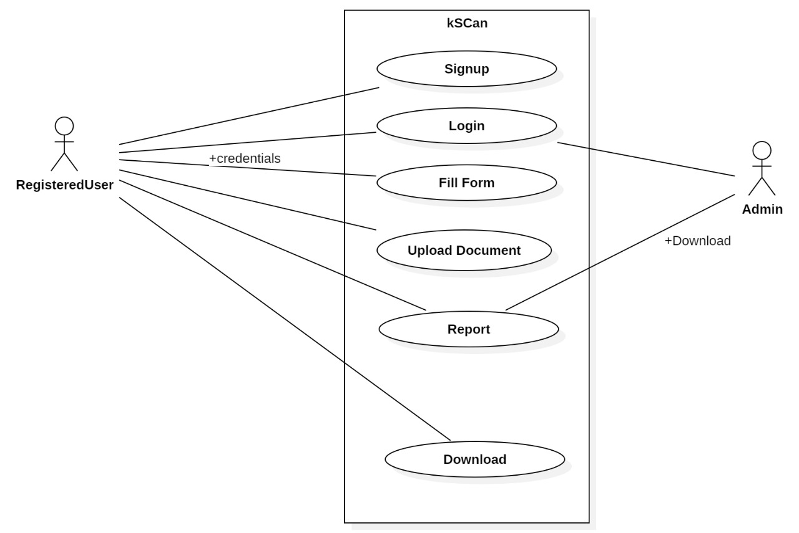

Installation of git:-
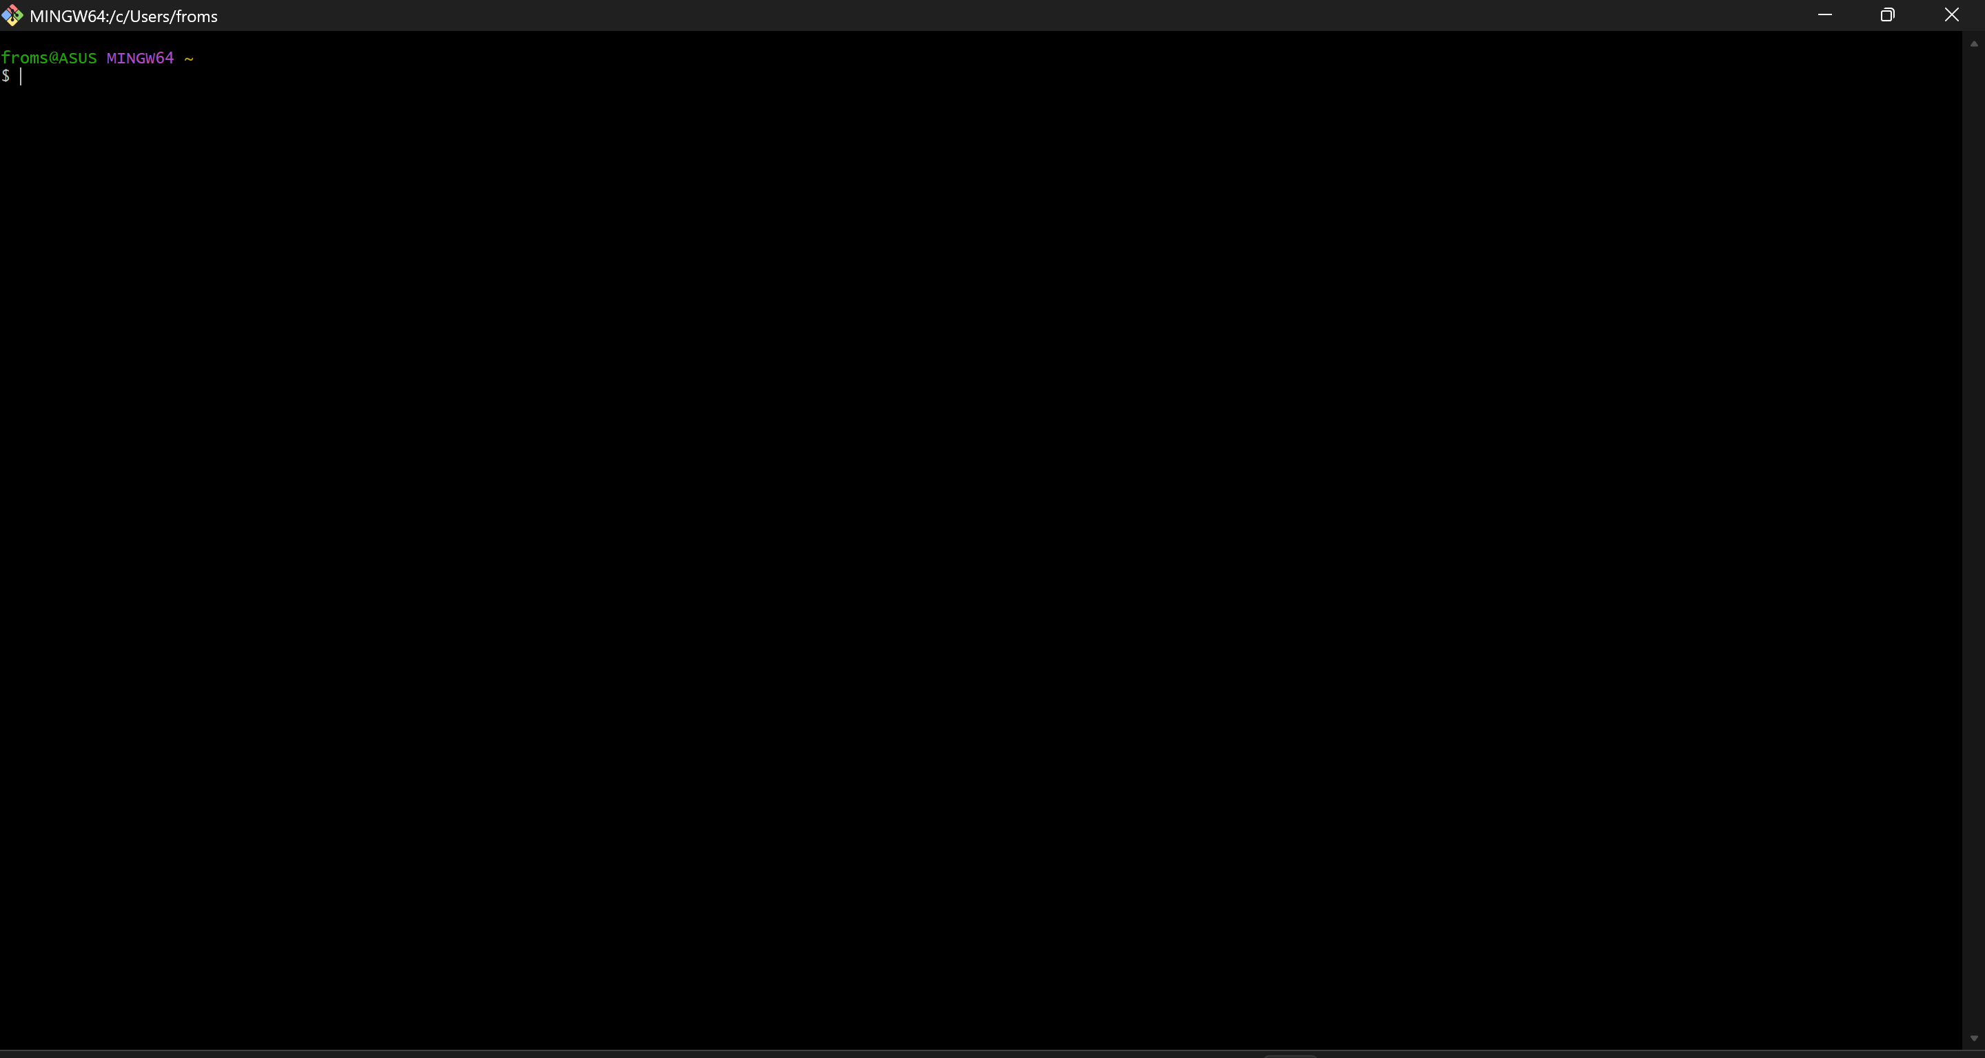

Installation of StarUML:-
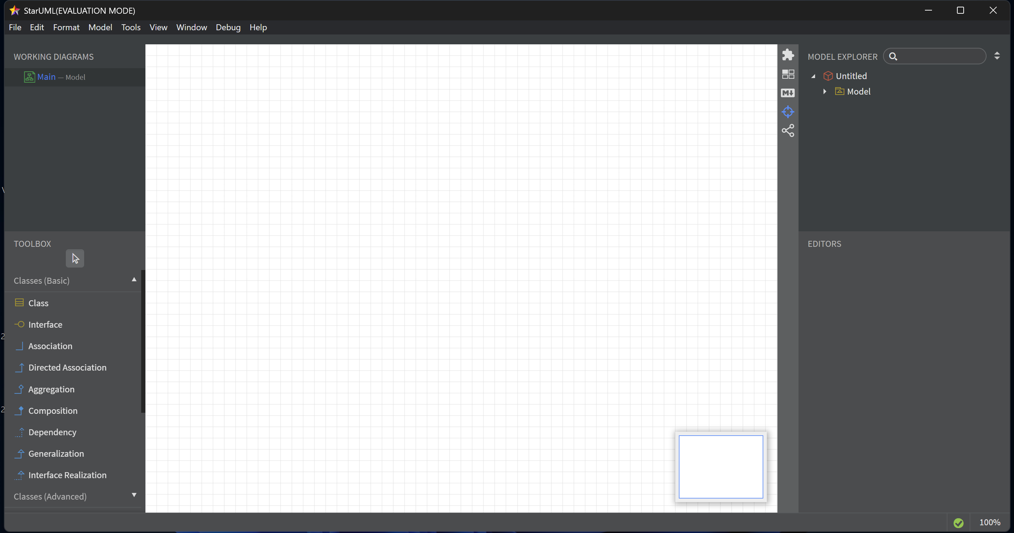
Git Account:-
